**TABLE CREATION**  
  
CREATE TABLE IBS_STUDENTS (

Student_id INT PRIMARY KEY,

Name varchar(25),

City varchar(15),

Phone_number INT,

Section varchar(1)

);

INSERT INTO IBS_STUDENTS (Student_id, Name, City, Phone_number) Values

(0101, 'Vipin Narang', 'Jaipur', 623034);

Select * from IBS_STUDENTS

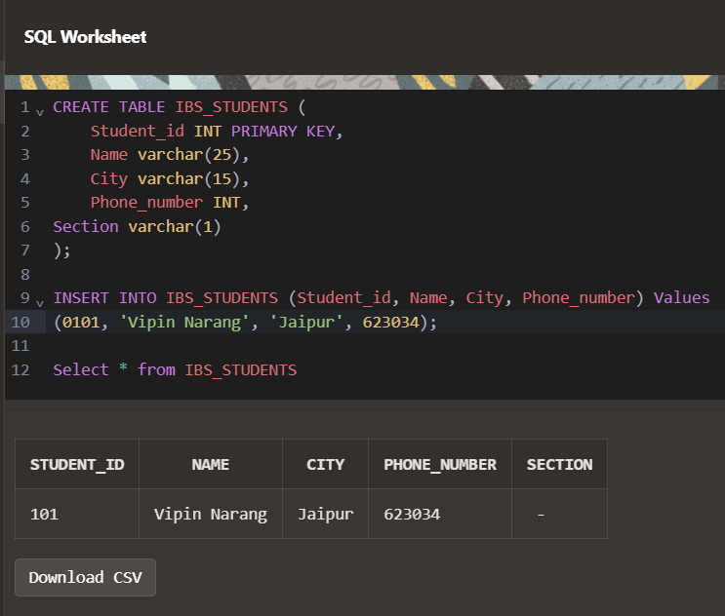

CREATE TABLE IBS_STUDENTS (

Student_id INT PRIMARY KEY,

Name varchar(25),

City varchar(15),

Phone_number INT,

Section varchar(1)

);

INSERT INTO IBS_STUDENTS (Student_id, Name, City, Phone_number) Values

(0101, 'Vipin Narang', 'Jaipur', 623034);

Update IBS_STUDENTS set Section =G

Select * from IBS_STUDENTS